DESIGN AND CONSTRUCTION OF A SIMPLE BURGLAR ALARM SYSTEM

BY

ABIOYE FRANCIS ADEBOWALE

EEE/11/0379

A PROJECT REPORT SUBMITTED TO THE DEPATMENT OF

ELECTRICAL/ELECTRONICS ENGINEERING, FEDERAL UNIVERSITY OYE-EKITI,

EKITI

IN PARTIAL FULFILLMENT OF THE REQUIREMENT FOR THE AWARD

OF

BACHELOR DEGREE(BEng. ELECTRICAL/ELECTRONICS ENGINEERING)

DECLARATION

I Abioye Francis Adebowale hereby declare that this project work carried out is the result of my personal effort and has not been submitted elsewhere for this purpose. All sources of information are duly acknowledged by means of references.

………………………………. ………………………….
Abioye Francis Adebowale DATE
EEE/11/0379

CERTIFICATION

This project work is titled “burglar alarm system” by Abioye Francis Adebowale, meets the requirement for the award of Bachelor of Engineering (B.Eng.) degree in Electrical/Electronic Engineering Department, Federal University Oye-Ekiti, Ekiti.

……………………………. …………………………….
ENGR TEMIDAYO OFUSORI DATE
(Project supervisor)

……………………………… …………………………
DR. O. AKINSANMI DATE
(Head of Department)

DEDICATION

This thesis is dedicated to Almighty God who spared my life throughout till this moment in sound and good health.
My gratitude also goes to my beloved parents Mr. and Mrs. E.O Abioye for their love, care and encouragement, also for their financial and moral support given to me. My greeting also extends to all member of my family, who in one way or the other have positively contributed to the success of my academic pursuit.

ACKNOWLEDGEMENT
My profound gratitude goes to the almighty God for his grace, mercy and protection throughout the period of my degree programed, also to my immediate family who strive each day to make sure the dreams of me being an Engineer is actualized, my siblings who go out of their ways to ensure I get all I need for my academics pursuit, I love you all.
I cannot but appreciate the principal partner of my supervisor in person of Engineer Temidayo Ofusori for his contributions towards achieving the purpose of this project work and my colleagues for their support during my project work. My profound gratitude is not only to those I have mentioned their names but also to several others especially my colleagues at school who have contributed in one way or the other to my success.
To the head of department, all lecturers and staff of the department of Engineering, Federal University Oye Ekiti, Ekiti State, I say a very big thanks to you all for your tips and guides over the years. Thanks for your support.

ABSTRACT
This work present the design, construction and testing of a simple burglar alarmactivated by light, break beam and pressure sensor. The principle of operation of this burglar alarm is simple. When the ray of light falls on the light sensor the alarm is triggered and the siren begins to operate, the speaker beeps and the flasher
(light) flashes.
When an intruder walks through the break beam sensor the alarm is triggered and the siren begins to operate, the speaker beeps and the flash light flashes. Likewise the pressure foot sensor has the same mode of operation. Whenever pressure is exerted on the foot sensor the alarm is triggered and the siren begins to operate. The speaker beeps and the flasher (light) flashes. These actions thus alert the owner of the residence and/or security personnel of the presence of an intruder.

TABLE OF CONTENTS

ACKNOWLEDGEMENT 6
ABSTRACT 7
LIST OF FIGURES 9
LIST OF TABLE 11
LIST OF ABBREVIATION 12
CHAPTER ONE 14
1.0 INTRODUCTION 14
1.1 PREAMBLE 14
1.2 PROJECT MOTIVATION 14
1.3 AIM 14
1.4 OBJECTIVES 14
1.5 SCOPE OF THE PROJECT 15
1.6 LITERATURE REVIEW 15
CHAPTER TWO 17
2.0 THEORETICAL BACKGROUND 17
2.1 TIMER 17
2.2 COMPARATOR 18
2.3 Power Transformer 18
2.4 BRIDGE RECTIFIER 19
2.5 The Capacitor Filter 19
2.6 DIODES 20
2.7 RESISTORS 20
SYSTEM DESIGN 26
3.1 INTRODUCTION 26
3.2 THE POWER SUPPLY UNIT 26
3.2.1 SELECTION OF FILTERING CAPACITOR 27
3.2.2 SELECTION OF RECTIFIER DIODES 28
3.2.3 SELECTION OF TRANSFORMER 29
3.2.4 SELECTION OF VOLTAGE REGULATOR 29
3.3 SENSING STAGE 30
3.4 LOGICAL CONTROL UNIT 31
3.5 SYSTEM BLOCK DIAGRAM 33
3.5.1CIRCUIT DIAGRAM OF BURGLAR ALARM SYSTEM 35
CHAPTER 4 36
TESTING AND CONSTRUCTION 36
4.1 INTRODUCTION 36
4.1.2 TESTING 36
4.1.3 CONSTRUCTION 37
4.1.4 PROBLEMS ENCOUNTERED 37
4.1.5 IMPLEMENTATION AND CASING 38
4.1.6 ANALYSIS OF BILL QUANTITY 38
CHAPTER 5 43
5.1 CONCLUSION AND RECOMMENDATIONS 43
5.2 LIMITATIONS 43
5.3 RECOMMENDATIONS 44
REFERENCES 45

LIST OF FIGURES

Figure 1 Internal crcuitry of a 555 timer configured in monostable mode.
Figure 2 One Shot Monostable
Figure 3 Non inverting comparator source.
Figure 4 Transformer.
Figure 5 Transformer wiring .
Figure 6 Voltage Regulator IC.
Figure 6.1 Full-wave rectifier with a capacitor filter.
Figure 7 Circuit diagram of power supply .
Figure 8 Diode symbol
Figure 8.1 Characteristics of Diode.
Figure 9.0 size of resistor
Figure 9.1 Resistor color code
Figure 9.2 Resistor color code
Figure 9.3 Resistor connection
Figure 9.4 resistor behaviour
Figure 10 Power supply circuit.
Figure 11 The ripple gradient of the power supply.
Figure 12 Break- beam sensor.
Figure 13 Comparator design circuit.
Figure 14 14IC555 timer configure in monostable mode.
Figure 15 Block diagram .
Figure 16 Testing project .
Figure 17 Construction of hardware.
Figure 18 casing.

LIST OF TABLE

Resistor Color Code ……………………………………………………………….1
Analysis of bills quantity …………………………………………………………….2

LIST OF ABBREVIATION

LED……………………………………………………………………..Light Emitting diode

IC………………………………………………………………………… Integrated Circuit

DC ………………………………………………………………………….. Direct Current

CHAPTER ONE

1.0 INTRODUCTION

1.1 PREAMBLE

The project presents the design, construction and testing of a simple activated burglar alarm. The principle of operation of this burglar alarm is simple. When there is reflection of light, pressure on the foot sensor or break beam through the door, the alarm is triggered and the siren begins to operate. The speaker beeps and the flasher (light) flashes. These actions thus alert the owner of the residence and/or security personnel of the presence of an intruder.

1.2 PROJECT MOTIVATION

What really inspired me is the expansion of standard of living which has driven the high level of crimes, particularly home raid and business premises robberies which happens daily.
Definitely fencing, burglar bars on doors and windows are now distant from the necessity of home security, other than that these systems should be switched with well modernized and burglar alarm system.

1.3 AIM

The aim of this project is to design and construct a workable, reliable and effective burglar alarm system that is activated by light, break beam or pressure sensor.

1.4 OBJECTIVES

The following are the objectives of this project.
- To design a system that will detect an intruder breaking a beam into a confined place
- To design a system that will alert the user when a ray of light falls on the confined place
- To design a system that will detect an intruder when stepping on a foot sensor.

1.5 SCOPE OF THE PROJECT

The scope of this project include the design and construction of a light sensor, design and construction of break beam sensor as well as design and construction of pressure sensor. It also includes the integration of all these sensors to produce an alarm sound for alert purpose and flasher for indicator purpose.
.

1.6 LITERATURE REVIEW

This chapter will emphasize on the research carried; intricate on ways in which this will assist the design at end. Investigations of past home burglar alarm security system devices and well modernized systems on the market to be attained. Every home owner and tenant are at risk of losing their hard earned possessions to burglars. This has prompted them into looking for more effective systems which provide higher security to their homes. In that way it will bar burglars from their premises, they will not gain access to their property easily without alarm and flasher alert immediately. In most domestic alarm systems the intruder detection facility is needed only when the building is unoccupied. From the alarm company’s point of view, multiple switching or zoning is justified on the grounds of ease of maintenance and locating and isolating faults should they occur. For some alarm companies to supply rather more comprehensive control panels than are strictly necessary, it is unknown and perhaps just to increase the sale value of the installation and probably to impress the customer.
According to research, the common parameters or characteristics of home security system are
− 24 hours monitoring of the intruder
− Ease of use
− Reliability
− Efficient

Fast and precise notification system. Today a number of home security systems are available everywhere.
A project on “design and Implementation of Security Systems for Smart Home based on GSM technology” [1], was implemented, they made use of web camera. Whenever there is a motion in front of the camera, it gives security alert in terms of sound and a mail is delivered to the owner. The second method sends SMS which uses GSM-GPS Module (sim548c) and Atmega644p microcontroller, sensors, relays and buzzers.
Also a project on “sound Activated Burglar Alarm System”[2] was implemented.The principle of operation is based on intensity of sound, when the intensity of sound exceeds certain level the alarm is triggered and the siren begins to operate.
A project on “ low cost Short Message System (SMS) based home security system equipped with motion sensor, smoke detector, temperature sensor, humidity sensor and light sensors ’’ has been studied by Mae , Y,; SaaS , N .; Inonu ,K. and Await. [3]

CHAPTER TWO

2.0 THEORETICAL BACKGROUND

This chapter takes a look at the theoretical use of the major components used for the implementation of the project. Each of these components is the key to the proper operation of the burglar alarm system.

2.1 TIMER
The 555 timer is an exceptionally useful accuracy IC that can act as either a timer or an oscillator. In timer mode, also known as monostable mode—the 555 basically acts as a “one-shot” timer; when a trigger voltage is applied to its trigger lead, the chip’s output goes from low to high for a period set by an external RC circuit. In oscillator mode—well know as astable mode—the 555 acts as a rectangular-wave generator whose output waveform (low duration, high duration, frequency, etc.) can be attuned by means of two external RC charge/discharge circuits.
The 555 timer IC is easy to use (requires few components and calculations) it is cheap and can be used in an astonishing number of applications. For example, with the aid of a 555, it is possible to generate digital clock waveform generators, LED and lamp flasher circuits, tone-generator circuits (sirens, metronomes, etc.), one-shot timer circuits, bounce-free switches, triangular-waveform generators, frequency dividers, etc. In this design, we configure 555 Timer in Monostable Mode[4].

How 555 Timer works in monostable mode.
IC 555 hooked up in the monostable configuration (one-shot mode). Unlike the astable mode, the monostable mode has only one stable state.
This means that for the output to switch states, a visibly applied signal is needed.
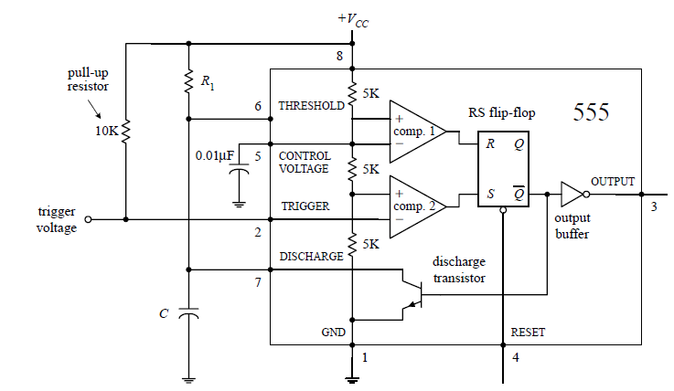
FIG. 1 INTERNAL CIRCUITRY OF A 555 TIMER CONFIGURED IN MONOSTABLE MODE .[4]

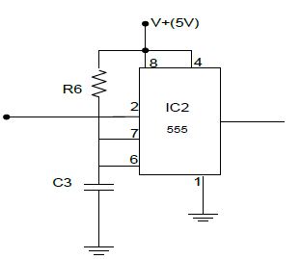
The monostable circuit only has one stable state. That is, the output rests at 0 V (in reality, more like 0.1 V) until a negative-going trigger pulse is applied to the trigger lead—pin 2. (The negative-going pulse can be implemented by momentarily grounding pin 2, say, by using a pushbutton switch attached from pin 2 to ground.) After the trigger pulse is applied, the output will go high (around VCC − 1.5 V) for the duration set by the R1C network. Without going through the derivations, the width of the high output pulse is t width = 1.10R1C. [2]

FIG. 2 One Shot Monostable Source:[5]

2.2 COMPARATOR
A comparator circuit compares two voltage signals and determines which one is greater. The result of comparison is indicated by the output voltage: if the op-amp’s output is saturated in the positive direction, the non- inverting input (+) is greater or more positive than the inverting input (-), all voltages are measured with respect to ground. If the op-amp’s voltage is near the negative supply voltage ( i.e 0 or ground potential), it implies the inverting input (-) has a greater voltage applied to it than the non-inverting input(+) .[6]
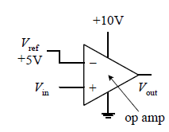

FIG. 3 non inverting comparator source: [2].

2.3 Power Transformer
Generation of electrical power in low voltage level is very much cost operational. Hence electrical power is produced in low voltage level. Ideally, this low voltage level power can be conveyed to the receiving end. But if the voltage level of a power is increased, the current of the power is reduced which causes reduction in ohmic or I²R losses in the system, reduction in cross sectional area of the conductor i.e. reduction in capital cost of the system and it also advances the voltage regulation of the system. Because of these, low level power must be paced up for proficient electrical power transmission. This is done by step up transformer at the sending side of the power system network. As this high voltage power may not be distributed to the consumers directly, this must be stepped down to the preferred level at the receiving end with the help of step down transformer. These are the uses of electrical power transformer in the electrical power system.
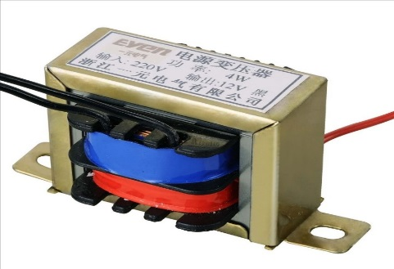
Fig.4 Transformer

BASIC PARTS OF A TRANSFORMER
In its most basic form a transformer consists of:
- A primary coil or winding.
- A secondary coil or winding.
- A core that supports the coils or windings.
Refer to the transformer circuit in figure below as you read the following explanation: The primary winding is connected to a 60-hertz ac voltage source. The magnetic field (flux) builds up (expands) and collapses (contracts) about the primary winding. The expanding and contracting magnetic field around the primary winding cuts the secondary winding and induces an alternating voltage into the winding. This voltage causes alternating current to flow through the load. The voltage may be stepped up or down depending on the design of the primary and secondary windings.
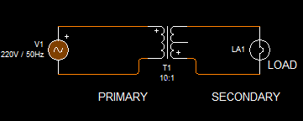
FIG. 5 Transformer wiring

2.4 BRIDGE RECTIFIER

A bridge rectifier is an arrangement of four or more diodes in a bridge circuit configuration which provides the same output polarity for either input polarity. It is used for converting an alternating current (AC) input into a direct current (DC) output. A bridge rectifier provides full-wave rectification from a two-wire AC input, therefore resulting in lower weight and cost when compared to a rectifier with a 3-wire input from a transformer with a center-tapped secondary winding.[6]
REGULATOR IC (78XX)
It is a three pin IC used as a voltage regulator. It converts unregulated DC current into regulated DC current.

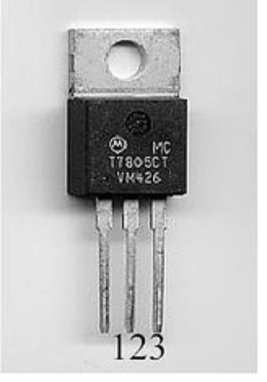
FIG. 6 Voltage Regulator IC
Normally we get fixed output by connecting the voltage regulator at the output of the filtered DC (see in above diagram). It can also be used in circuits to get a low DC voltage from a high DC voltage (for example we use 7805 to get 5V from 12V). There are two types of voltage regulators:
1. Fixed voltage regulators (78xx, 79xx) 2. Variable voltage regulators (LM317).In fixed voltage regulators there is another classification i.e.:
1. +ve voltage regulators 2. -ve voltage regulators
POSITIVE VOLTAGE REGULATORS: This include 78xx voltage regulators. The most commonly used ones are 7805 and 7812. 7805 gives fixed 5V DC voltage if input voltage is in (7.5V, 20V).

2.5 The Capacitor Filter
The simple capacitor filter is the most basic type of power supply filter. The application of the simple capacitor filter is very limited. It is sometimes used on extremely high voltage, low-current power supplies for cathode ray and similar electron tubes, which require very little load current from the supply. The capacitor filter is also used where the power-supply ripple frequency is not critical; this frequency can be relatively high.

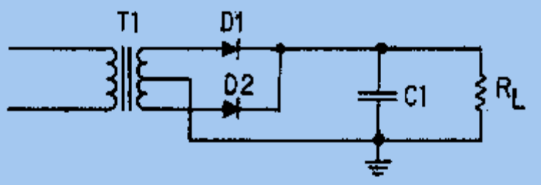
FIG. 6.1 Full-wave rectifier with a capacitor filter.

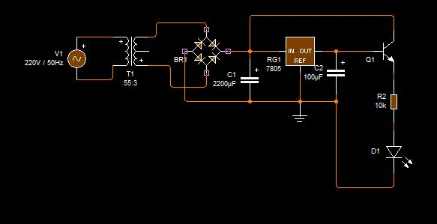
FIG.7 CIRCUIT DIAGRAM OF POWER SUPPLY

2.6 DIODES
A diode is a two-lead semiconductor device that acts as a one-way gate to electric current flow. When a diode’s anode lead is made more positive in voltage than its cathode lead—a condition referred to as forward biasing—current is permitted to flow through the device. However, if the polarities are reversed (the anode is made more negative in voltage than the cathode)—a condition referred to as reversed biasing—the diode acts to block current flow. Diodes are used most commonly in circuits that convert ac voltages and current into dc voltages and currents (e.g., ac/dc power supply). Diodes are also used in voltage- multiplier circuits, voltage-shifting circuits, voltage-limiting circuits, and voltage- regulator circuits.[2]

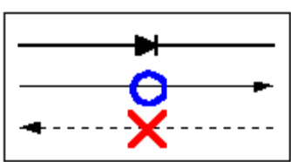Fig.8.0 Diode Symbol

This symbol is used to indicate a diode in a circuit diagram. The meaning of the symbol is (Anode) (Cathode). Current flows from the anode side to the cathode side.
Although all diodes operate with the same general principle, there are different types suited to different applications. For example, the following devices are best used for the applications noted.

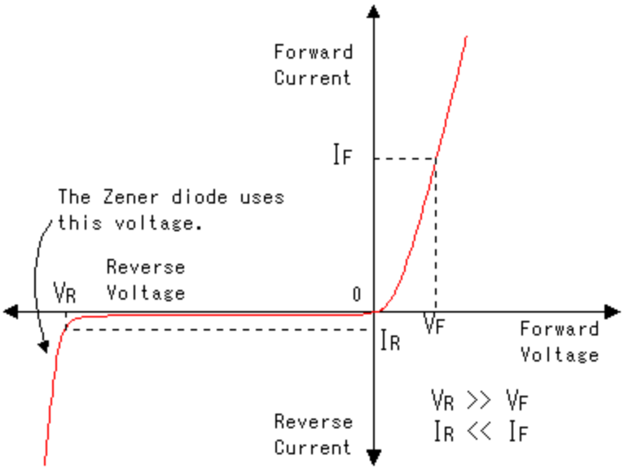
FIG.8.1 Characteristics of Diode ^{[7]}

2.7 RESISTORS
Resistors
A resistor is a passive two-terminal electrical component that implements electrical resistance as a circuit element. Resistors act to reduce current flow, and, at the same time, act to lower voltage levels within circuits.[8]
Fixed Resistors
A fixed resistor is one in which the value of its resistance cannot change.
Carbon film resistors
This is the most general purpose, cheap resistor. Usually the tolerance of the resistance value is ±5%. Power ratings of 1/8W, 1/4W and 1/2W are frequently used.
Carbon film resistors have a disadvantage; they tend to be electrically noisy. Metal film resistors are recommended for use in analog circuits. However, I have never experienced any problems with this noise. The physical size of the different resistors is as follows
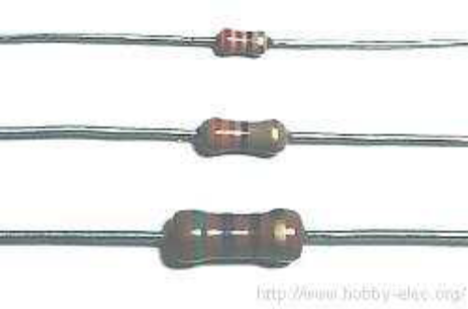Rough size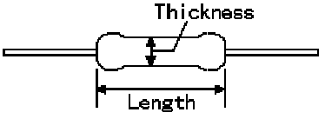
FIG. 9.0 Size of resistor.
Rating power Thickness Length
From the top of the diagram (W) (mm) (mm)

1/8W 1/8 2 3
1/4W 1/4 2 6
1/2W 1/2 3 9

The physical size of the different resistors

Color | Value | Multiplier | Tolerance (%)
Black | 0 | 0 | -
Brown | 1 | 1 | ±1
Red | 2 | 2 | ±2
Orange | 3 | 3 | ±0.05
Yellow | 4 | 4 | -
Green | 5 | 5 | ±0.5
Blue | 6 | 6 | ±0.25
Violent | 7 | 7 | ±0.1
Gray | 8 | 8 | -
White | 9 | 9 | -
Gold | - | -1 | ±5
Silver | - | -2 | ±10
None | - | - | ±20
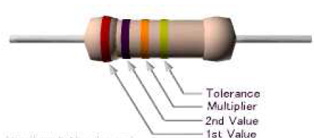
TABLE 1. RESISTOR COLOR CODE
Fig.9.1 Resistor color code
Example 1
(Brown=1), (Black=0), (Orange=3) =10 x 10³ = 10k ohm, Tolerance (Gold) = ±5%

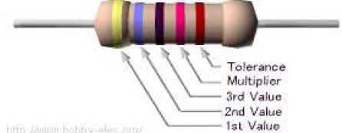
Fig.9.2 Resistor color code[6]
Example 2
(Yellow=4), (Violet=7), (Black=0), (Red=2) =470 x 10² = 47k ohm, Tolerance (Brown) = ±1%

Variable Resistors
Variable resistors provide varying degrees of resistance that can be set with the turn of a knob.
Special kinds of variable resistors include potentiometers, rheostats, and trimmers. Potentiometers and rheostats are essentially the same thing, but rheostats are used specifically for high-power ac electricity, whereas potentiometers typically are used with lower-level dc electricity. Both potentiometers and rheostats are designed for frequent adjustment. Trimmers, on the other hand, are miniature potentiometers that are adjusted infrequently and usually come with pins that can be inserted into printed-circuit boards. They are used for fine-tuning circuits (e.g., fine-tuning a circuit that goes astray as it ages), and they are usually hidden within a circuit’s enclosure box. Variable resistors come with two or three terminals.
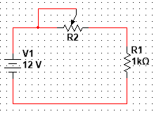
FIG.9.3 Resistor Connection
When purchasing variable resistors, make sure that you understand the distinction between linear-tapered and nonlinear-tapered variable resistors. The “taper” describes the way in which the resistance changes as the control knob is twisted.

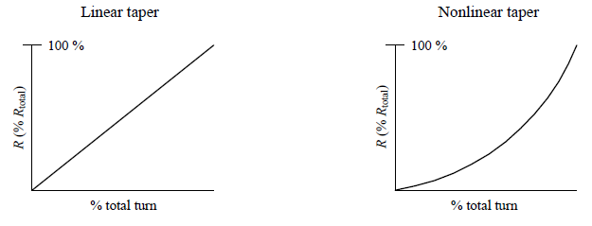
FIG.9.4 Resistor Behavior
Why do variable resistors come with nonlinear tapers? Well, as it turns out, human physiology has a weird way of perceiving changes in signal intensity, such as sound and light intensities. For example, you may think that if you doubled the intensity of sound or light, you would perceive a doubling in sound and light. Unfortunately, at least in terms of intuition (not in terms of safety control for our brains) humans do not work this way. In fact, our perceptions of sight and sound work as follows: Perceived loudness/brightness is proportional to log10 (actual intensity measured with a nonhuman instrument). Thus, if you are building an amplifier for a set of speakers or building a home light-dimming circuit, it would be wise to use a variable resistor with a nonlinear taper.

CHAPTER THREE

SYSTEM DESIGN

3.1 INTRODUCTION

An intruder blocks a projected infrared beam (in an opto-isolator) and generates a clock pulse, the same thing happens when a ray of light falls on the light dependent resistor. The opto-isolator is made up of an infrared transmitter and a photo-diode receiver.In view of all the varieties explored in the earlier preview section, we notice that many dissimilar types of alarm systems that can be used for household safety, there are some systems which are in place already and some still under examination to the world market. At the moment, many systems which are available on the market they contain features of electronic systems which are mostly in use to offer necessary safety for the home and those systems can be customized according to the necessary requirement. The system’s alarm will be triggered if;
- An intruder interrupt the opto-isolator
- A ray of light falls on the Light Dependent Resistor
- An intruder step on switch 1

3.2 THE POWER SUPPLY UNIT
The power supply stage provides the appropriate DC voltage requirements to ensure the circuit components (especially the Active components) are powered properly. The circuit uses +5VDC supply. The power supply stage is a linear power supply type and involves a step down transformer, Rectifier, Filter capacitor, and a voltage regulators, to give the regulated DC voltage.
The circuit for the power supply stage is shown in fig 10 below.
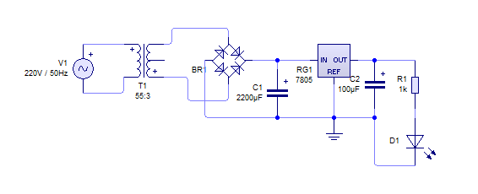
FIG. 10 POWER SUPPLY CIRCUIT

3.2.1 SELECTION OF FILTERING CAPACITOR

The rectifier is designed with four diodes to form a full wave bridge network C1 is the filter capacitor while C2 is inversely proportional to the ripple gradient of the power supply. Fig. 5 shows the ripple gradient of the power supply.
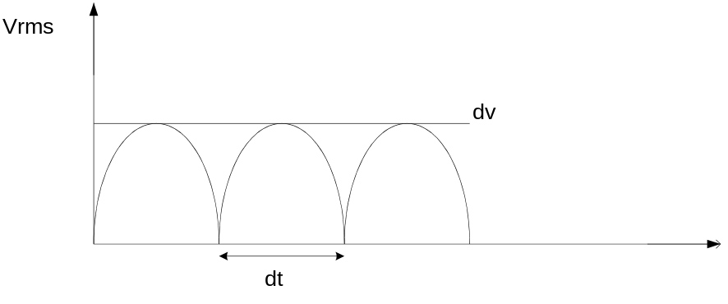
FIG. 11 THE RIPPLE GRADIENT OF THE POWER SUPPLY.

Where dv is the ripple voltage for time dt, where dt is a dependent in power supply frequency.
ANALYSIS

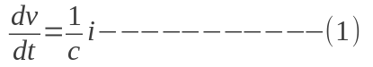

Where: 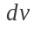 = ripple voltage
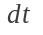 = period
= capacitance value (C1) and,
= load current
Since the output of the transformer is 12v rms, the peak value of the voltage will be;
Vpeak = Vrms × 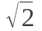

If we set an allowable ripple of 20%, then
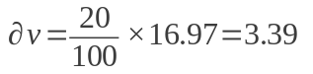
From (1), 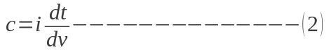
Where dt is 10ms for 50HZ
CV= It
C= IV/t
T= 1/F = 1/50 = 0.02S
BUT;
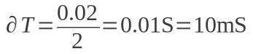
From equation (2), we have;
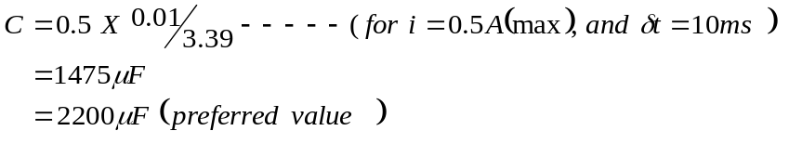

The value of dt = 10ms for a frequency of 50Hz, full wave rectification, while the maximum. Current expected from the power supply is 0.5A. C2 filters any noise at the output of the regulator to ensure smooth operation of the ICs.

3.2.2 SELECTION OF RECTIFIER DIODES

An IN4001 Diode was used in the rectifying circuit for it is perfect for most low voltage circuits where the current is less than 1A. It was ensured that the current flowing through these Diodes from the transformer output would not cause any damage since their forward voltage drop is almost constant irrespective of the current passing through them.
- The DC voltage across the diode was calculated as follows;

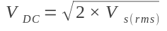--------------------------------- (3)

Where

Vs(rms) = Secondary AC voltage (15V)

Therefore,

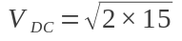

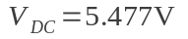

Hence we go for the available one which is 7.07V.

3.2.3 SELECTION OF TRANSFORMER

In order to achieve the required DC power by the IC’s, a step down transformer of primary windings voltage of 220V and secondary winding voltage of 15V was used. The transformer was assumed in an ideal situation which implies a unity power factor.
For an ideal transformer, we have;
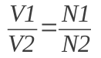 ----------------------------- (4)
Therefore, 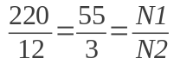
This implies that the turns ratio for the transformer used is 55:3.

3.2.4 SELECTION OF VOLTAGE REGULATOR

This is the last stage in ripple elimination and setting the DC output to a fixed value. In order to derive a quality precision, LM7805 is used in performing the task regulation. Its features includes: Maximum output current of 1.5A, fixed output voltage of 5V, thermal shutdown, etc.[6]. We ensured that the input voltage to a voltage regulator is within the stated input voltage range as a result, the designed input voltage of LM7805 regulator.

3.3 SENSING STAGE

The opto-isolator is made up of an infrared transmitter and a photo-diode receiver. When the beam is broken, the output of the LM393 op-amp in the detector stage goes low, to allow for the appropriate trigger condition of the monostable stage. Fig 12 below shows the break-beam sensor stage.
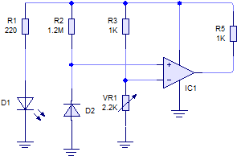
FIG 12 Break-Beam sensor stage.

ANALYSIS
For the infrared emitter (D1),
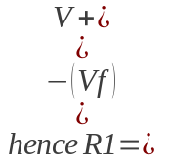 -------------------------------- (5)

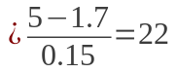

This value is however for maximum range. To conserve current 220Ω has been used since the lab model is for a very short range.
The photo diode was used as the main opto-sensor due to its ability to resist day light interference better than the other optical devices mentioned. The photodiode is operated in reverse biased condition. In darkness (i.e. without infrared transmission) or during break-beam the photodiode has a high resistance, and a low resistance upon reception of infrared light. The change in resistance causes a change in the drop across the diode, which is fed to the input of the comparator IC1. The resistance measured from the photodiode when there is no transmission is approximately 1M. From figure 12 R2 a potential divider network with the photo diode.
DESIGN CALCULATIONS.
Transmission resistance --------- 10kΩ
Break-beam resistance----------- 1MΩ
Voltage across diode during transmission,
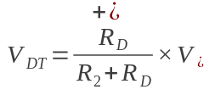------------------------------------------ (6)
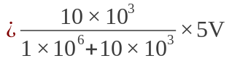
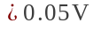 (This value is approximately zero volts. Hence during transmission the diode output gives 0V).
Voltage across diode during break-beam is,
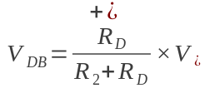 ------------------------------------------- (7)
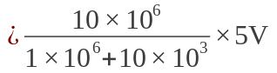
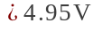
The two voltage levels are still influenced by the presence of daylight interference and the separation distance between the transmitter and the receiver. To ensure two distinct levels a voltage comparator is used. The comparator stage allows a precise point to be set where the output voltage will change. This is achieved by adjusting VR1 in fig 12 above.
Setting VR2 to 2.0V means any voltage above 2.0V in the inverting input (as the beam is broken) will make the comparator LOW. This LOW output is used to trigger a 555 timer one shot monostable that generates the clock pulse for the counting.
Since
Vout = A₀ ×Vin
Where A₀ = open loop voltage gain.
And Vin = V⁺ - V⁻
Vout will drop to V+ for the slightest positive difference in voltage since A0 is often very large (in order of 20000).
The comparator is meant to give a HIGH when the beam is broken and a LOW when the infrared is transmitting to D2 (the photo diode).

3.4 LOGICAL CONTROL UNIT
3.4.1COMPARATOR DESIGN
A comparator circuit compares two voltage signals and determines which one is greater. The result of comparison is indicated by the output voltage: if the op-amp’s output is saturated in the positive direction, the non- inverting input (+) is greater or more positive than the inverting input (-), all voltages are measured with respect to ground. If the op-amp’s voltage is near the negative supply voltage (i.e 0 or ground potential), it implies the inverting input (-) has a greater voltage applied to it than the non-inverting input (+).

FIG. 13 COMPARATOR DESIGN CIRCUIT

3.4.2IC555 TIMER DESIGN
MONOSTABLE MODE
The 555 timer IC is an exceptionally useful accuracy timer that can act as either a timer or an oscillator. In timer mode, also known as monostable mode—the 555 basically acts as a “one-shot” timer; when a trigger voltage is applied to its trigger lead, the chip’s output goes from low to high for a period set by an external RC circuit. Sarath M et al. (2011). In this design, IC555 timer was configured in a monostable mode so as to achieve the required task.
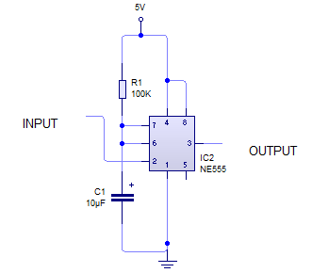

FIG. 14 IC555 Timer configured in a Monostable mode
If the period (T) of the IC is 5.2seconds and the capacitor C1 is choosen to be 47uF, then the design analysis for the IC555 Timer goes thus;
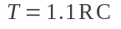------------------------------------- (8)
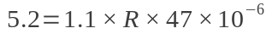
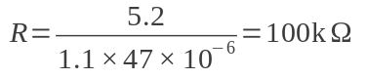
Therefore the value of Resistor R1 will be 100k.

3.4.3 ASTABLE MODE
Astable Multivibrator can be designed by using 555 timer IC, Op Amps and also using transistors. The 555 IC provide accurate time delay from milleseconds to hours.The frequency of oscillation can be controlled manually by simple modification. 555 is suitable for circuit designers with a relatively stable, cheap, and user-friendly integrated circuit for both monostable and astable applications. The 555 timer IC was first introduced around 1971 by the Signetics Corporation as the SE555/NE555. This is a simple 555 timer circuit project. Astable Multivibrator is simply an oscillator circuit that produces continuous pulses. The frequency can be controlled by changing the values of R2, R3 and C3.
If the period (T) of the IC is 0.65 second and the capacitor C2 is choosen to be 47uF, and R2=R3=R, then the design analysis for the IC555 Timer goes thus;
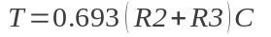
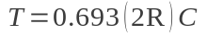
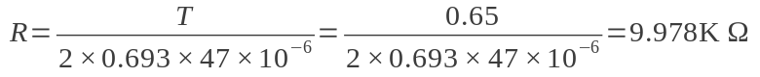
R = 10K
R2=R3=10K

3.5 SYSTEM BLOCK DIAGRAM

The approach used in this work is the modular approach where the overall design was
first broken into functional block diagrams, where each block represents a section of the
circuit that carries out a specific function.LIGHT SENSOR
BREAK BEAM SENSOR
FOOT SENSOR
POWER SUPPLY
LOGICAL CONTROL DELAY TIMER
ALARM
SPEAKER

FIG 15 Block diagram.

CIRCUIT DIAGRAM OF BURGLAR ALARM SYSTEM

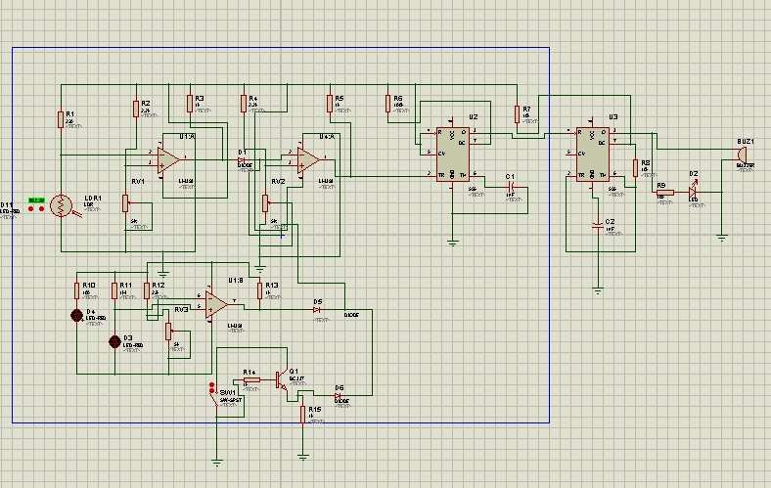

FIG 16Circuit Diagram.

CHAPTER 4

TESTING AND CONSTRUCTION

4.1 INTRODUCTION
This chapter also discusses the hardware section of the project. It gives details of the pictures used during construction and some elaborate explanation of the devices used. This entails the construction and testing of the burglar alarm system.

4.1.2 TESTING
The physical realization of the project is very vital. This is where the whole idea meets reality. As the designer, I am able to see my work not just on paper but also as a finished hardware.
After carrying out all the paper design and analysis, the project was implemented and tested to ensure it’s working ability, and was finally constructed to meet desired specifications. The testing of the project was first done on a breadboard whereby all the component used for the project were affixed into a breadboard as it is in the circuit diagram. Usually it is not expected to work at first attempt and so each connection terminal is checked carefully to make sure that they are all fitted in perfectly on the breadboard. Also, another testing is done when the components have all been soldered on the Vero board, before the final work is put in a casing. At this point, the working principle of the project is tested to make sure it is working perfectly before coupling and casing.
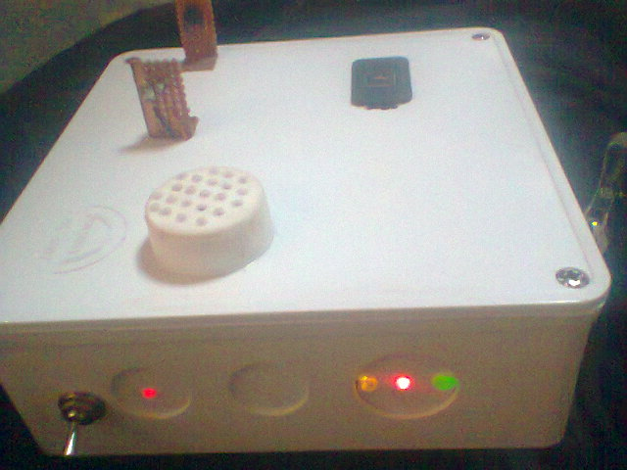

FIGURE 17: Testing project

The process of testing involved the use of some test and measuring equipment stated below.
(i) BENCH POWER SUPPLY: This was used to supply voltage to the various stages of the circuit during the breadboard test before the power supply in the project was soldered. Also during the soldering of the project the power supply was still used to test various stages before they were finally soldered.
(ii) OSCILLOSCOPE: The oscilloscope was used to observe the ripples in the power supply waveform.

The output voltage from our variable bench power supply was checked to make sure the frequency is 0 (i.e. dc).
(iii) DIGITAL MULTIMETER: The digital multi-meter basically measures voltage, resistance, continuity and current. The process of implementation of the design on the board required the measurement of parameters like, voltage, continuity, and current resistance values of the components. The digital multi-meter was used to check the output voltage supply in this project.

4.1.3 CONSTRUCTION

The construction commenced with the soldering of the components to the board and testing. For the soldering the following steps were taken;
All jumper wires were soldered first
Followed by integrated circuit sockets
The tip of the soldering iron was tinned to avoid dry solder joints
Each stage on the Vero board was tested as soldering progressed
The wires were rated to match necessary power required, like the mains, jumper wires etc.
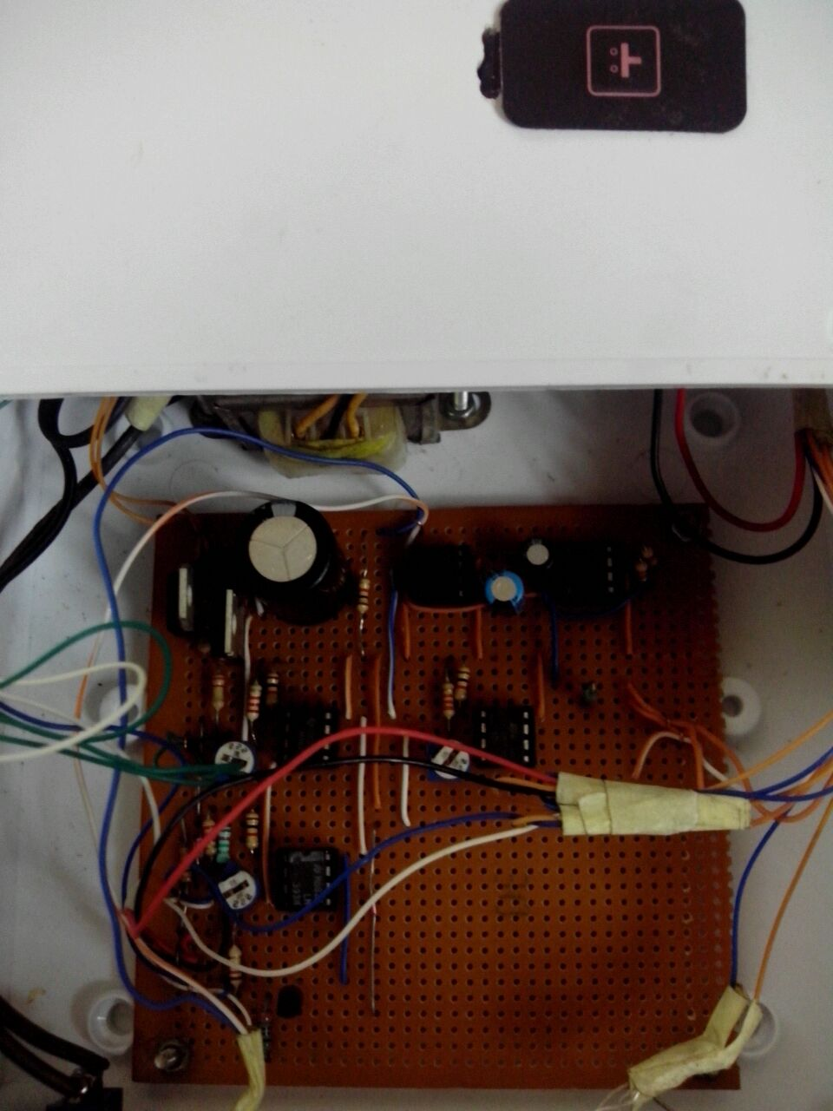
FIG 18 Construction of hardware.

4.1.4 PROBLEMS ENCOUNTERED

The following problems are list of the problems encountered during the project construction to implementation.
- During implementation, I discovered there was daylight interference which impaired the sensitivity of the break-beam stages. This problem was solved by shielding the infrared sensors from daylight using an infrared filter.
2 The circuit generated noise whenever the alarm was set off, this was due to the relatively large current drained from the DC power supply by the alarm module. To remove this noise a capacitor was put across the 12V supply rail as well as the 5V supply rail and a voltage follower and heat sink was used for the 12V regulator.

4.1.5 IMPLEMENTATION AND CASING

The implementation of this project was done on the breadboard.
Stage by stage testing was done according to the block representation on the breadboard, before soldering of circuit commenced on Vero board. The various circuits and stages were soldered in tandem to meet desired workability of the project. There was a lot of modification in the process of construction which led to the modification of the circuit diagram.
The second phase of the project construction is the casing of the project.
This project was coupled in a metal casing. The casing material being wrought metal, designed with special perforation and vents and also sprayed to ensure insulation.

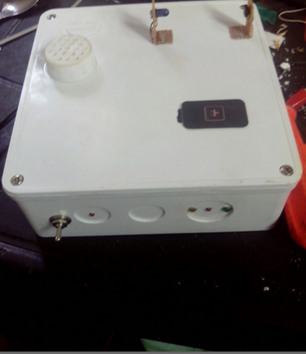
FIG 19 Casing.

4.1.6 ANALYSIS OF BILL QUANTITY

COMPONENT | COST | QUANTITY | TOTAL
Lm 393 | 200 | 3 | 600
Bpw42(IR ) | 400 | 1 | 400
Resistor | 20 | 20 | 400
capacitor | 50 | 6 | 300
transformer | 800 | 1 | 800
Vero board | 400 | 1 | 400
casing | 1500 | 1 | 1,500
4mHz crystal | 400 | 1 | 400
Soldering and iron lead | 1500 | 1 | 1,500
Bpw41 | 500 | 2 | 1,000
NE555 | 100 | 2 | 200
Receiver | 150 | 1 | 150
LDR | 40 | 1 | 40
Variable resistor | 20 | 3 | 60
22OOµF | 80 | 1 | 80
47µF | 30 | 2 | 60
Diode | 20 | 4 | 80
Infrared | 200 | 3 | 600
Jumper wire | 20 | 5 | 100
speaker | 350 | 1 | 350
transportation | 2000 |  | 2,000
 |  |  | 11,020

Table 2:Analysis of bill of quantity

CHAPTER 5

5.1 CONCLUSION AND RECOMMENDATIONS

The project which is the design and construction of a burglar alarm system was designed considering some factors such as application, design economy, availability of components and research materials, efficiency, compatibility and portability and also durability. The performance of the project after test met design specifications
A simple sound activated burglar alarm system has been designed, constructed and
tested. It is suitable for indoor security especially in small rooms jewelry stores and art galleries. This burglar alarm is thus very good for safe guarding valuables.

The construction was done in such a way that it makes maintenance and repairs an easy task and affordable for the user should there be any system breakdown.

5.2 LIMITATIONS
The project worked according to design specification but has the following limitations.
- The project has no means of alerting a security personnel far away from the device, the personnel has to be close by to hear the alarm and see the flashes to take necessary action.
- The project also does not include sound and motion detection sensors within it’s design.

5.3 RECOMMENDATIONS
Like every other work, this work is not without its limitations and can be improved
upon. On this basis recommendations have been made for improvement.

A connection to a telephone dialer that can dial the security and relay a preprogrammed message with the address of the burglary scene can also be incorporated for better efficiency.

A transducer that detects movement and sound can be used can be used to increase the sensitivity and the overall effectiveness of the burglar alarm.

REFERENCES

[1] Jayashri Bangali and Arvind Shaligr, Design and Implementation of Security Systems for Smart Home based on GSM technology. 2013

[2] Mahmud Shehu AHMED, Abubakar Sadiq MOHAMMED, Genesis Abah AGBO,development of a Simple Sound Activated Burglar Alarm System.Published by Leonardo Journal of Sciences.2006
[3] Mae , Y,; SaaS , N .; Inonu ,K. ; Await.; “Person Detection by Mobile Manipulator for

Monitoring”,SICE 2003 Annual Conference, pages-2801-2806.
[ 4] Paul Scherz. Practical electronics for inventors (page 273-274). Published by Mcgraw – Hild(2000).
[5] George Love Day, Essential Electronics (page 241- 244) Transistor , Published by Pitman (1984).
[6] www.allaboutcircuits.com
Last Visit: 06/03/2016, 2:31pm
[7] www. Futureelectronics.com /en/diodes/bridge- rectifier . aspx.
Last Visit: 10/22/2015, 2:31pm
[8] IR Bidirectional Visitors Counter by HB con Labs.

