STUDIES IN THE DEPROTEINIZATION POTENTIAL OF COCONUT WATER (COCOS NUCIFERA) NATURAL RUBBER LATEX

BY

OLADIPUPO OLATUNDE ELIJAH
(CHE/13/1399)

BEING A DISSERTATION SUBMITTED TO THE DEPARTMENT OF INDUSTRIAL CHEMISTRY, FEDERAL UNIVERSITY OYE-EKITI, EKITI STATE.

IN PARTIAL FULFILLMENT OF THE RECQUIREMENT FOR THE AWARD OF BARCHELOR OF SCIENCE (HONS) DEGREE IN INDUSTRIAL CHEMISTRY

November 2017

CERTIFICATION
This is to certify that Oladipupo Olatunde Elijah with matriculation number CHE/13/1399 has completed his research project in partial fulfillment of the requirement for the Award of Bachelor of Science (Hons) Degree in Industrial Chemistry at Federal University Oye-Ekiti, Ekiti-State.

_________________________ _____________________
DR. P.O. Okolo Date
HOD

_________________________ _____________________
DR. D. Malomo Date
SUPERVISOR

_________________________ _____________________
DR. O. Egharevba Date
CO-SUPERVISOR

Dedication
I dedicate this work to God, the source of my life, my parents who assisted me financially and my able lecturers and staff of the Department of industrial Chemistry, Federal University Oye –Ekiti, who have been impacting knowledge in me all these years.

ACKNOWLEDGEMENT
My profound and ultimate gratitude goes to Almighty God, who has been my help, protector and sustainer, during and after the duration of my project. He is worthy of continual appreciation and each time I call on him he has always been faithful.
I want to appreciate my supervisor, Dr D. Malomo for his fatherly and financial support as well as his counsel and to my co-supervisor Dr O. Egharevba for his technical input in this research work. .
I also want to appreciate the Head of Department Dr P. Okolo, all my lecturers as well as the entire member of staff of the Department of Industrial Chemistry and Federal University Oye-Ekiti for their training and mentorship.
I will forever appreciate my parents; Mr and Mrs kolawole Oladipupo, my siblings and relatives, for their timely support, I also acknowledge my entire course mates, showed me the meaning of love and family most especially Olubuade Nurudeen, Amos Patrick, good friends who are more like brothers.

TABLE OF CONTENTS

CONTENT PAGE
Title page I
Certification II
Dedication III
Acknowledgement IV
Tables of Contents V
List of Tables VIII
List of Figures IX
Abstract X
CHAPTER ONE: INTRODUCTION
- Introduction 1
1.1 Natural Rubber Latex 2
  - Production of Natural Rubber Latex 3
1.3 General Properties of Natural Rubber Latex 3
1.4 Application of Natural Rubber Latex 5
1.5 Protein in Natural Rubber Latex 5
1.5.1 Protein on the Surface of the Rubber Particle 6
1.5.2 Protein in the C-Serum 6
1.5.3 Protein in the Bottom Fraction 6
1.6 Deproteinization of Natural Rubber Latex 7
1.7 Comparative Composition of Natural Rubber Latex 10
1.8 Latex Coagulation 10
1.9 Latex allergies 11
CHAPTER TWO: LITERATURE REVIEW
2.1 Effect of Deproteinized Methods on the Proteins 12
2.2 Preparation of Deproteinized Natural Rubber Latex and Properties of Films Formed 12

2.3 Deproteinization of Natural Rubber Using Protease Immobilized on Epichlorohydrin Cross-linked Chitosan 13

2.4 Removal of Proteins from Natural Rubber Using Urea 13
2.5 Stability and vulcanization characteristics of enzyme deproteinized natural rubber latex 14

2.6 Review on Previous Deproteinization Techniques used in Natural Rubber Latex 14
2.7 Scope of Present Study 15
CHAPTER THREE: MATERIALS AND METHODS
3.1 Collection of the Sample 17
3.2 Materials 17
3.2.2 Apparatus and Equipment 17
3.2.3 Chemicals 18
3.3 Methodology 18
3.4 Characterization of Natural Rubber Latex 19
3.4.1 Density19
3.4.2 pH Analysis 19
3.4.3 Dry Rubber Content (%) 19
3.4.4 Total Solid Content (%) 20
3.5 General Formulation of the Deproteinizing Agent 21
3.6 Deproteinization of Natural Rubber Latex 21
3.7 Nitrogen Analysis 22
CHAPTER FOUR: RESULT AND DISCUSSIONS
4.1 Protein Content (%) 25
4.2 Conclusion 28
4.3 Recommendation 28
REFRENCES 29

List of Tables
Title Page
Table 1.1: Composition of NR Latex in Emulsion and Dry Forms 9
Table 3.1: General Formulation of the Deproteinizing Agent 21
Table 4.1: Characterization of 1% Ammonia Preserved Latex 24
Table 4.2: Protein Analysis on Deproteinized Natural Rubber 26

List of Figures
Title Page
Figure 1.0: Rubber Tapped in Malaysia 8
Figure 1.1: Rubber Plantation 8
Figure 1.2: Chemical Structure of Natural Rubber 8
Figure 4.1: Mass after Drying 25
Figure 4.2: Mass before Drying 25
Figure 4.3: A plot of Protein Content against Concentration of Deproteinizing agent
27

Abstract
The use of untreated natural rubber latex for the production of dipped goods has suffered a major setback due to numerous complaints of allergy traced to inherent protein content, a number of conventional treatment substances have been reported such as urea, papain and bromelain. The challenges in the use of these substances range from the cost to environmental problems. The use of coconut water being a natural product as a potential deproteinizing agent in natural rubber latex has therefore been investigated. Amount of coconut water ranging from 0.0, 0.1, 0.2, 0.3, 0.4, 0.5 and 1.0 % v/v in 1% ammonia preserved latex were analysed. The results obtained showed that coconut water has potential for use as deproteinizing agent as they were reductions in protein content (%) for all samples except for 0.2 and 0.3 v/v which remained indifferent. The most efficient formulation gave a value of 48% reduction in protein content corresponding to 0.5% v/v coconut water in latex. These result suggest that coconut water when properly applied to latex can reduce the protein content by a mechanism suspected to be mechano-chemical arising from centrifugation and enzymatic hydrolysis.

CHAPTER ONE
1.0 INTRODUCTION
Natural rubber, also called India rubber or caoutchouc as initially produced, consists of polymers of the organic compound isoprene, with minor impurities of other organic compounds, and water. Malaysia and Indonesia are two of the leading rubber producers in the world. Forms of polyisoprene that are used as natural rubbers are classified as elastomers. Natural rubber has characteristic properties such as large enlongation, high elasticity, high tensile strength and tear strength and satisfactory coating film strength. Natural rubber is utilized in wide variety of products including household materials such as gloves for surgeries and contraceptives. Rubber is harvested mainly in the form of the latex from the rubber tree. Raw rubber comes from the field or plantation in two basic forms: field latex and field coagula.
Natural Rubber Latex contains a small amount of non-rubbers, which include a variety of protein and which have played a role in the biosynthesis and stabilization of rubber latex within the vessels of the tree. The latex of Hevea brasiliensis is a complex colloidal dispersion of biochemical components consisting of polyisoprene latex rubber particles and non-rubber components in an aqueous serum phase. Some adverse effects of these non-rubbers are well documented. These non-rubbers continue to play a role in the subsequent processing behavior of the Natural Rubber Latex, its long-term stability, and catalyzing crosslinking reactions through free radical and ionic mechanisms resulting in covalent bonds. The protein sheath, which may be amphoteric in nature, around the latex particle is conjectured to facilitate the movement of curatives, usually carbon-, sulfur-, and nitrogen-containing materials, into the latex particles by providing an intermediate transport mechanism from the water phase to the rubber phase. The removal of the non-rubbers in treated Natural Rubber Latex slows down the maturation process, hence translating into a longer “pot life.”
Rubber is used as raw material in many products today, which can be divided into two main types, i.e. natural and synthetic rubber. Raw natural rubber involves processing fresh latex or field coagula obtained by cutting the rubber tree, into a raw material ready for use in making rubber products further on. Raw materials in the natural rubber industry consist of fresh (field) latex, obtained by cutting rubber trees, and field coagula, which include cup coagula, cup lump, tree lace, bark scraps, earth scraps and smoked sheet cuttings, etc.

1.1 NATURAL RUBBER LATEX
The latex is a sticky, milky colloid drawn off by making incisions in the bark and collecting the fluid in vessels in a process called "tapping". The latex then is refined into rubber ready for commercial processing. In major areas, latex is allowed to coagulate in the collection cup. The coagulated lumps are collected and processed into dry forms for marketing. There are different rubbers such as Hevea brasilienisis, congo rubber, dandelion e.t.c.
Latex is the polymer cis-1, 4-polyisoprene with a molecular weight of 100,000 to 1,000,000 daltons. Typically, a small percentage (up to 5% of dry mass) of other materials, such as proteins, fatty acids, resins, and inorganic materials (salts) are found in natural rubber. Polyisoprene can also be created synthetically, producing what is sometimes referred to as "synthetic natural rubber". Natural rubber is an elastomer and a thermoplastic, but as rubber is vulcanized, it turns into a thermoset. Most rubber in everyday use is vulcanized to a point where it shares properties of both; i.e., if it is heated and cooled, it is degraded but not destroyed. Naturally coagulated rubber (cup lump) is used in the manufacture of TSR10 and TSR20 grade rubbers. Processing of these grades is a size reduction and cleaning process to remove contamination and prepare the material for the final stage of drying. The dried material is then baled and palletized for storage and shipment (Hosler et al.,1999).

1.2 PRODUCTION OF NATURAL RUBBER LATEX
Rubber tree is an important industrial crop for natural rubber production. Latex comes from the Hevea brasiliensis tree, which grow in tropical regions. They typically reach 20-30 meters in height in the rubber plantations, and are able to produce commercial quantities of latex at about 7 years of age, depending on climate and location. Hevea latex is collected through tapping of trees in the natural forest.

1.3 GENERAL PROPERTIES OF NATURAL RUBBER LATEX
Rubber exhibits unique physical and chemical properties. Some of the properties are stated below:
- Natural rubber combines high strength (tensile and tear) with outstanding resistance to fatigue.
- It has moderate resistance to environmental damage by heat, light and ozone which are one of its drawbacks.
- The natural rubber has excellent adhesion to brass-plated steel cord, which is ideal in rubber tyres.
- It has low hysteresis which leads to low heat generation, and this in turn maintains new tyres service integrity and extend retreability
- The natural rubber has low rolling resistance with enhanced fuel economy.
- It has high resistance to cutting, chipping and tearing.
- Macromolecules of natural rubber are long, regular, flexible and practically linear, thus it has very good elastic properties.
- It has chemical structure of cis-1,4-polyisoprene
- It has a molecular weight beyond 100,000
- Typically, a small percentage (up to 5% of dry mass) of other materials, such as proteins, fatty acids, resins and inorganic materials (salt) are found in natural rubber.
- Elasticity is the fundamentally important property of natural rubber. Rubber is unique in the extent to which it can be distorted, and the rapidity and degree to which it recovers to its original shape and dimensions.
- It is strong and tough. Because of this property it can be put to use even under abnormal conditions
- It is highly impermeable to both water and air and therefore, it can be used to retain water as in rubber bottles, hoses etc.
- It exhibits a great resistance to abrasion, tearing and cutting over a wide range of temperature
- It is a bad conductor of heat
- It can contain liquid and gas
- When two fresh surface of milled rubber are pressed together, they coalesce to form a single piece. This property, known as tackiness of rubber, makes the manufacturing of composite articles, such as tyres possible.
- The plasticity of rubber makes it pliable and amenable to all manufacturing processes
- By vulcanizing the rubber, its mechanical properties can be considerably improved
The electrical insulating properties of pure rubber are inferior to those of vulcanized rubbers (Leonid Viktorovich, 2009)

1.4 APPLICATIONS OF NATURAL RUBBER LATEX

- Natural rubber forms an excellent barrier to water.
- This is possibly the best barrier against pathogens such as the AIDS virus (HIV). That is the reasons why latex is used in condoms, catheters, surgical or medical gloves.
- Natural rubber is an excellent spring materials
- Natural rubber latex is also used in balloons, medical tubes, elastic thread, and also in some adhesives.
- It is used by automotives industry
- The flexibility of rubber is appealing in hoses, tyres and rollers used in printing
- It elasticity makes it suitable for various kinds of shock absorbers and for specialized machinery mounting designed to reduce vibrations.
Because of their electrical resistance, soft rubber goods are used as insulation and for protective gloves, shoes and blankets; hard rubber is used for articles such as telephone housings, parts for radio sets, meters and other electrical instrument (Leonid Viktorovich, 2009).
1.5 PROTEIN IN NATURAL RUBBER LATEX

The total protein content in latex has been estimated to be about 2-3%, however, discrepancies in the distribution of the proteins between the major phases of latex exist. Report shows that 20% of the total proteins were absorbed on the rubber surface, 66% in the C-serum and 14% in the bottom fraction.
1.5.1 Proteins on the surface of the rubber particle
The existence of proteins in association with phospholipids on the surface of rubber particles was recognized as early as 1953 by Bowler. The attributed that this protein phospholipid layer imparted a net negative charge to the colloidal stability of these particles. By measuring the iso-electric points of various latex samples, he concluded that there was more than one protein adsorbed on the rubber surface and that the relative proportion of the adsorbed proteins varied with clones.
1.5.2 Protein in the C-serum
Nearly half of the enzymes examined in natural rubber latex glycolytic appeared to be located in the C-serum of latex. These include enzymes for the pathway as well as many of the enzymes for rubber biosynthesis. The first protein to be isolated from natural rubber latex was from C-serum and it was named α-globulin.

1.5.3 Protein in the bottom fraction
Proteins in the bottom fraction are essentially studied as the soluble proteins in B-serum. These have been examined with various techniques, including paper electrophoresis, starch gel electrophoresis etc. (Ferreira et al., 2009).

1.6 DEPROTEINIZATION OF NATURAL RUBBER LATEX
Denaturation helps in protein reduction and removal of undesirable residual protein, and there are several ways of doing this which would be reviewed here. The different methods include saponification, surfactant washing and enzymatic treatment.
The cleavage of proteins in NR latex was found to proceed with concomitant formation of low molecular weight polypeptides. This results in lowering gel formation of the enzyme-treated latex, indicating modification of the remaining proteins at the rubber chain-end. Washing NR latex with surfactant would efficiently reduce and remove proteins from NR latex particles through denaturation and transferring them to the serum phase. The relatively stable gel formed during storage of surfactant-washed NR latex is an indication of the absence of branch formation of proteins at the rubber molecule terminal. Saponification by strong alkali would hydrolyze the proteins and phospholipids adsorbed on the latex particle surface. The reason of the significantly higher gel formed in saponified NR latex is still not clear. The present study shows that deproteinization treatments result in modification of the proteins at the surface of NR latex particles and also those freely-suspended in the serum. The cleavage or the denaturation of the rubber proteins during purification by washing has a profound effect on the properties of the deproteinized NR latex upon storage, in particular the thermal oxidative aging properties of the rubber obtained.

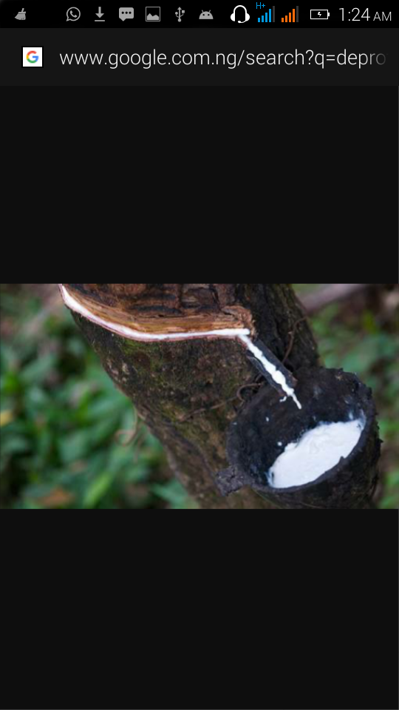
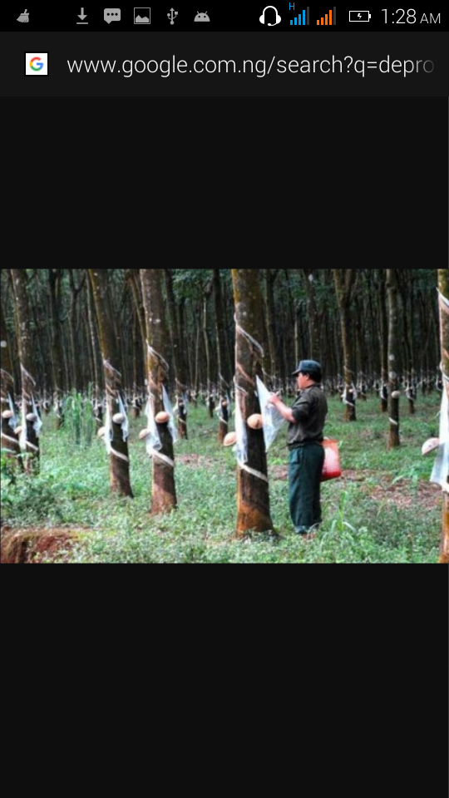
Fig 1.0 Rubber tapped in Malaysia fig 1.1 Rubber Plantation
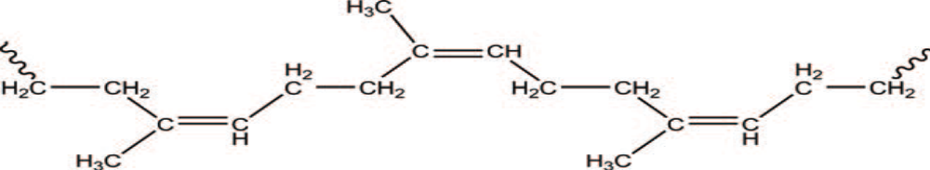
Fig 1.2 (a) Chemical structure of NR [cis-1, 4-poly (isoprene)], where the chemical
Structure of isoprene is 2-methyl-1, 3-butadiene and (b) NR latex from a Hevea tree on a rubber estate, Malaysia

Table 1.1 Compositions of NR latex in emulsion and dry forms.
 | Component | Composition (%)
NR latex | Total solid content  Dry rubber content  Resinous substances  Proteinaceous substances  Inorganic salts (mainly K, P and Mg)  Ash  Sugars  Water | 36  33  1-2.5  1-1.5  0.5  <1  1  60
Dry NR | Rubber content  Resinous substances  Proteinaceous substances  Inorganic salts  Sugars  Cu and Mg  Water | 93–95  2  2-3  <0.2  <0.2  2–3 ppm  0.5
Deproteinized dry NR | Rubber content  Proteinaceous substances  Ash  Volatile matter content  Dirt content | 96  0.12  0.15  0.3  0.01
1.7 COMPARATIVE COMPOSITION OF NATURAL RUBBER LATEX
The typical compositions of NR latex, dry NR and deproteinized dry NR (DPNR) are tabulated in Table 1.1. DPNR latex is a premier NR latex, treated with special enzymes or complexed with other chemicals to break down the naturally-occurring proteins. DPNR has improved resistance to fatigue failure for Engineering Applications. They are important in the manufacture of dipped goods for medical applications.

1.8 LATEX COAGULATION
The objective of coagulation is to separate the serum (liquid phase in latex) and the coagulum as completely as possible. The development of coagulum can be induced by the addition of acid. Natural rubber latex coagulation is achieved by neutralizing the negative charges on the rubber particles so that they coalesce. In the coagulation procedure the solid rubber is separated from the serum fractions.
Coagulation is the process by which a liquid is changed to a thickened, cordlike, insoluble state by chemical reaction. The natural coagulation may also result from enzyme activities from Hevea latex and from contaminating microorganisms or microbial metabolism in latex. The normal latex coagulation methods are acid coagulation and assisted biological coagulation.
Normal coagulation is carried out by acidifying latex from approximately neutral (pH of about 7), to pH 5.4. Inorganic acids are used for coagulating skim rubber, but they tend to be too aggressive for coagulating field latex and they leave residues that quickly corrode processing machinery. In practice, formic acid is preferred for normal coagulation but acetic acid is also used, along with formic acid. Excellent separation with virtually no rubber left in the serum can be achieved simply by properly adjusting the pH.
Assisted biological coagulation is a process that can be carried out by autocoagulation without the addition of acid. Auto-coagulation is not widely used,
However, for various reasons:
(i) the rubber produced by auto-coagulation is inferior in certain characteristics and often has offensive smell.
(ii) coagulation takes about 48 hours, much longer than with acid coagulation,
(iii) rubber recovery is often incomplete. Some of these disadvantages have been overcome by Assisted Biological Coagulation, (ABC). ABC is a process developed by RRIM, in which the microbiological production of acid is accelerated by adding sugar.
1.9 LATEX ALLERGIES
A latex allergy is a reaction to products made from natural rubber latex, whereby the allergy-causing particles become attached to the cornstarch powder in gloves, swimming caps and balloons with moisture from the skin enhancing the process. The particles can become airborne and inhaled when products are used. With some individuals reacting to this particles. Milk protein is sometimes mixed with latex in surgical and household gloves and this can be the cause of reactions in milk allergic individuals (Aprem et al., 2002).

CHAPTER TWO
LITERATURE REVIEW

2.1 EFFECT OF DEPROTEINIZED METHODS ON THE PROTEINS
Three different methods of deproteinization, i.e. saponification, surfactant washing and enzymatic treatment have been reported as methods of deproteinizing natural rubber (NR) latex. The cleavage of proteins in NR latex was found to proceed with concomitant formation of low molecular weight polypeptides. This results in a lowering in gel formation of the enzyme-treated latex, indicating modification of the remaining proteins at the rubber chain-end. Washing NR latex with surfactant would efficiently reduce and remove proteins from NR latex particles through denaturation and transferring them to the serum phase (Kanjanee et al., 2010).

2.2 PREPARATION OF DEPROTEINIZED NATURAL RUBBER LATEX AND PROPERTIES OF FILMS FORMED
This deproteinizing effect of some adhesives on Natural Rubber Latex such as: hydroxypropylmethyl cellulose (HPMC), methyl cellulose (MC), sodium carboxymethyl cellulose (SCMC), poly (vinyl alcohol) (PVA), poloxamer 407, and sodium alginate was carried out by (Wiwat et al., 2012). The work was aimed at identifying the best film that would be appropriate for medical and pharmaceutical applications. Dibutyl phthalate (DBP), diethyl phthalate, dibutyl sebacate, triethyl citrate, and glycerin (GLY) were used as plasticizers to improve the elasticity and adhesiveness of the novel materials. DNRL was prepared by proteolytic alcalase enzyme treatment, followed by centrifugation.

2.3 DEPROTEINIZATION OF NATURAL RUBBER USING PROTEASE IMMOBILIZED ON EPICHLOROHYDRIN CROSS-LINKED CHITOSAN.

Deproteinization of natural rubber using an alkaline protease from Bacillus sp. immobilized on cross-linked chitosan beads is reported. Conditions were identified for attaining a high activity of the immobilized enzyme on the beads. The optimally produced enzyme beads were then used to establish the conditions for effective deproteinization of natural rubber. A two-level full factorial design was used to quantify the main effects and the interaction of the factors influencing the formation of the catalytic beads and the rubber deproteinization process. Results of the workers showed that by using the optimal deproteinization process, the total nitrogen level in the rubber was reduced from 0.35% to 0.013%w/w, or a >96% nitrogen removal. In contrast, the urea method of deproteinization achieved a lower nitrogen removal of <86%. (Sirawan et al., 2013).

2.4 REMOVAL OF PROTEINS FROM NATURAL RUBBER USING UREA

The removal of proteins from natural rubber through a batch process has been reported by the incubation of the rubber latex with urea in the presence of sodium dodecyl sulphate. (Phan-Trung et al., 2000). Their result under suitable conditions showed that the total nitrogen content of deproteinized natural rubber (DPNR) decreased from 0.38 to 0.02 wt % after incubation for 10 min; this was similar to that of the rubber deproteinized with a proteolytic enzyme for 12 h. For applications, continuous incubation and centrifugation were individually achieved by the use of a semicircular channel and a continuous centrifuge, respectively, to scale up DPNR preparation. The total nitrogen content of U-DPNR prepared through continuous incubation and centrifugation was quite similar to that prepared through a batch process, which was about 0.02 wt %. Result obtained here is similar to that of (warunee et al., 2013). where removal of proteins from natural rubber by incubation of high ammonium natural rubber latex (HA-NR) with urea 0.1wt% for 1 hour in the presence of surfactant at room temperature (DPNR) has been reported to reduce the nitrogen content of the DPNR reduced to 0.05wt%, which was lower than 0.45wt% of HA-NR under the test condition. The reduction of protein content was confirmed by observing the chemical structure through FT-IR technique. It was then found that the urea treatment is an effective method to remove protein from rubber latex.

2.5 STABILITY AND VULCANIZATION CHARACTERISTICS OF ENZYME DEPROTEINIZED NATURAL RUBBER LATEX

The colloidal stability of enzyme deproteinized natural rubber latex was investigated in comparison with the conventional high ammonia latex has been reported. The colloidal stability was found to improve by the addition of potassium hydroxide or a combination of potassium hydroxide and ammonium laurate during compounding (Rajammal et al., 2004) the mechanical properties and ageing resistance as reported were found to be within the limits specified for dipped goods.
2.6 REVIEW OF PREVIOUS WORKS ON DEPROTEINIZATION TECHNIQUES USED FOR NATURAL RUBBER LATEX
Several techniques are available to reduce the protein content of the latex, such as leaching, autoclaving, non-ionic surfactants, the use of proteolytic enzymes, centrifugation or a combination of mechanical and chemical processes.
Leaching is effective only when the process is empoled for a few hours and so it is not commercially viable in reducing protein content to greater level for production of dipped goods especially of medical application. Steam autoclaving can affect physical properties unless precautionary measures are taken at the compounding stage. The use of chlorination may affect the strength of the gloves and it reduces the color of the latex product, while centrifuging will only remove a part of the soluble proteins of the latex (Schloman, W.W, 2002).
Proteolytic enzyme like the use Bromelain from Pineapple juice is used to reduce protein content of latex, it has been reported that Bromelain is more effective than Papain because it is more suitable in the production of cyclized rubber and also because of the colour properties it has on the final product (Yapa et al., 1980). The use of Papain from Pawpaw extract (Yapa and Scnanayake, 1983), which serves two purposes; act as coagulant and reduction of nitrogen content of the latex has been reported to have substantially reduced the nitrogen content to about 30-50%

2.7 SCOPE OF PRESENT STUDY
The study is targeted at investigating the deproteinization potential of coconut water on natural rubber latex. The specific objectives are:
- characterization of natural rubber latex
- preparation of proteolytic enzyme
- centrifugation of the treated latex
- determination of the nitrogen content of the treated lattices using Kjeldahl method

CHAPTER THREE
MATERIALS AND METHODS
3.1 COLLECTION OF SAMPLES
Freshly tapped Natural Rubber Latex preserved with 1% ammonia was obtained from Rubber Research Institute of Nigeria (RRIN), Sapele road, Benin City, Edo state, while the coconut water was obtained by cracking coconut pods purchased in Benin City. The water was kept in sterilised containers and stored.

3.2 MATERIALS
3.2.2 Apparatus and Equipment
- Petri Dish
- Weighing balance: Sartorious Ag. Gottingen BP1215. Made in England.
- Test tubes
- pH meter
- Measuring cylinder SPG100ml Graduated Made in England.
- 45 micron sieve
- Centrifuge
- Sample bottles
- Conical flask: Pyrex SPG100ml Graduated Made in England.
- Volumetric flask
- Digestion tube
- Hot Plate Clifton hot plate HP1.30E Made in China.
- Titration Apparatus
- Oven GRIFFEN 300FC. Isuzu Seisakasho CO-LTD Tokyo Japan.
- Alfa Laval Centrifuge at 10,000 rpm
- Stop Watch: 31305 model Made in China.

3.2.3 Chemicals
- Acetic acid
- Ammonia
- Methanol
- Sodium dodecyl sulphate (SDS)
- Sulphuric acid (H₂SO₄)
- Se catalyst
- Sodium sulphate
- Copper sulphate
- Sodium hydroxide (NaOH)
- Distilled Water
- 1% Ammonia Preserved Natural Rubber Latex

3.3 METHODOLOGY
There are different methods of deproteinization of the natural rubber, the use of urea is often employed industrially and it is a non-enzymatic process hence, it was used as a control. In this case, the coconut water consist of bioactive enzymes such as catalases, hydrolases, peroxidase e.t.c. and therefore used for deproteinization.
3.4 Characterization of Natural Rubber Latex
The natural rubber latex used for this work was characterised for the following parameters:
- Density
- pH
- Total solid content
- Dry rubber content
- Protein content (% w/w)

3.4.1 Density
The density of latex was determined by taking the weight of 100ml water as well as that of 100ml 1% ammonia preserved latex, the density was interpreted as relative density by taking the ratio of the mass of 100ml latex to that of 100ml water.
3.4.2 pH Analysis
All pH values were taken by immersing the electrodes of the pH meter in distilled water, followed by the sample and reading the values as indicated on the meter.
3.4.3 Dry Rubber Content (%)
Determination of dry rubber content was carried out by measuring 10g of latex and precipitated with 75cm³ of acetic acid. The precipitation which was gradually executed was improved by the addition of methanol. The white solid coagulant which separates from the serum was allowed to stand for 24 hours. The coagulated rubber sample obtained was spread on clean flat surface. The flat rubber sheet was then dried in a laboratory oven at 75⁰c for 18 hours. The weight of the sheet was taken several times, after this period the constant value was obtained.
The DRC was calculated as follow: DRC = Weight of dry sample x 100%
Weight of Latex
3.4.4 Total Solid Content
Principle
A test portion of the latex was dried to constant mass under specified conditions, at atmospheric pressure. The total solids content was determined by weighing before and after drying to constant mass.
Heating at atmospheric pressure (70 °C) — Natural and rubber latex
2.0 g ± 0.5 g of latex was weighed, and the exact mass (M₀) was determined by weighing to the nearest 0.1 mg. The content of the dish was gently swirl to ensure that the latex covers the bottom .Then 1 cm3 of distilled water of equivalent purity was added and mixed with the latex by swirling. The dish was placed in the oven, and it was heated to about 70 °C for 16 hours until the test portion has lost its whiteness. The dish was removed from the oven and it was allowed to cool at ambient temperature in the desiccators. The dish was remove and weighed, and was returned into the oven for 30 min at 70 °C. The drying procedure was repeated for a period of 30 min until the loss in mass between the two successive weighing is less than 0.5 mg. The mass of the dried latex (M₁) was recorded
3.5 GENERAL FORMULATION OF THE DEPROTEINIZING AGENT
Table 3.1: The Level of Treatment of 100cm³ latex with 0.1, 0.2, 0.3, 0.4, 0.5cm3 of the coconut water.

Sample 1% ammonia preserved latex (cm³) Coconut water (%) SDS (%)
A 100 0.1 1.0
B 100 0.2 1.0
C 100 0.3 1.0
D 100 0.4 1.0
E 100 0.5 1.0
F 100 0.5 1.0

3.6 DEPROTEINIZATION OF NATURAL RUBBER LATEX
Deproteinizatin of natural rubber latex was carried out using natural rubber from Rubber Research Institute of Nigeria (RRIN), and preserved with 1% ammonia and stabilized with 1% Sodium dodecyl sulphate, The preserved latex was incubated with 0.1, 0.2, 0.3, 0.4, 1.0, 1.5 w/w % coconut water at room temperature . The level of nitrogen content in each sample was determined using the kjehdahl process, while the protein content was calculated.
The reference materials include 0.1 w/w% urea, uncentrifuged latex and untreated natural rubber but centrifuged without urea.
3.7 NITROGEN ANALYSIS
The protein content was determined by using the nitrogen analysis. 2.0g of 1% ammonia preserved latex was accurately weighed into 500cm³ Kjehdahl flask. 10g of sodium sulphate with 0.5g of copper sulphate and 25cm³ of concentrated sulphuric acid was added respectively and the mixture was shaken.
Protein + H₂SO₄ → (NH₄)₂SO_{4 (aq)} + CO_{2 (g)} + SO_{2(g)} + H₂O _{(g)} (1)
(latex)
The digestion flask was heated to about 390⁰c in the heating mantle, and the heating continued until the mixture turned from brown to a transparent green, the solution was allowed to cool before distillation.
The content of the digestion flask was washed with 300cm³ of deionized water into a distillation flask, the solution then made alkaline by adding 100cm³ of sodium hydroxide.
(NH₄)₂SO_{4 (aq)} + 2NaOH → Na₂SO_{4 (aq)} + 2H₂O _{(l)} + 2NH_{3(g)} (2)
The distillation apparatus was set in such a way that the ammonia distilled was trapped into 100cm³ of a standard hydrochloric acid in a conical flask. The trapped ammonia in the 100cm³ standard HCL was later titrated with 0.1 M NaOH using phenolphthalein indicator. The actual amount of the standard acid Acm³ which neutralises the ammonia was evaluated as follows:
A = 100-x
Where, x = Volume of 0.1M NaOH consumed to achieved the end point.
Calculations of the protein content were done as follows:
% Nitrogen content= Molarity of acid X Titre value X 0.014 X V₁ X 100
Weight of Sample V₂
%protein content are = F X %Nitrogen
Where f = 6.25
M = Molarity of acid
T = Titre value
W = mass of sample
V₁ = Initial volume of acid used
V₂ = Final volume of acid used
0.014 = Atomic mass of Nitrogen per thousand

CHAPTER FOUR
RESULTS AND DISCUSSION
Table 4.1: characterization of 1% Ammonia Preserved Natural Rubber Latex.
Parameter Sample (latex) Okiemen et al. (2004)
pH 10.08 6.5
Density (g/ml) 0.99 0.92
TSC (%) 35.20 35.00
DRC (%) 33.90 33.09

The pH of the 1% ammonia preserved field latex used was 10.08. The high alkalinity content when compared with freshly tapped field latex is due to the high ammonia preservation for stability during handling and further analysis in this work. The density of the polymer at 0.99g/ml conforms to the value found in literature.
The total solid content and dry rubber content all expressed in percentage represent latex rubber quality assurance parameters. For this test a value of 35.20 and 33.50 were obtained for TSC and DRC respectively. These values are in agreement with those of (okiemen et al., 2004) where 35.00 and 33.09 were obtained. The value of the dry rubber content is very ideal for the production of latex based goods such as prophylactics. The evaluation of this material is necessary since prophylactics are mainly medical goods where contact with the human body and tissues are common. The factors which affect the DRC include the tapping methods and physiological activities in the trees.
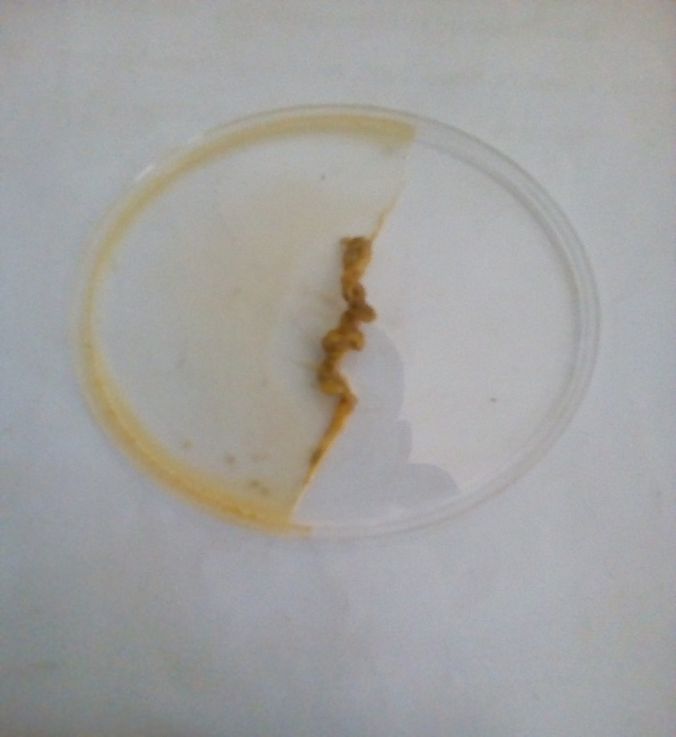
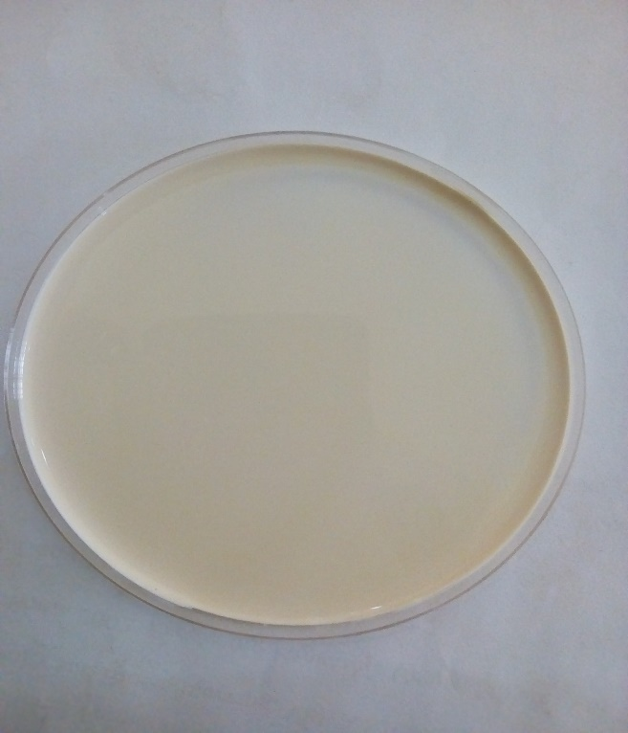

Fig 4.1: Mass after drying Fig 4.2: Mass before drying
4.1 PROTEIN CONTENT
The use of coconut water here used as a deproteinizing agent for natural rubber latex has been investigated. The treatment was carried out for 0.1,0.2,0.3,0.4,0.5, and 1.0 v/v% coconut water in natural rubber latex corresponding to samples A,B,C,D,E, and F, as well as a control which is 0.0 V/V% were investigated.
The result obtained are expressed in table 4.2 where the protein contents were determined by using nitrogen analysis through the micro kjehdahl method. From the results obtained, the protein content varied from 0.68-1.26 V/V% which corresponds to 0.5, 0.2 and 0.3 v/v% coconut water concentration respectively.

Table 4.2: Protein analysis on deproteinized natural rubber latex are shown in the table below.
Coconut water (% v/v) Nitrogen content (%) Protein content (%)
- 0.0 0.210 1.31
A 0.1 0.195 1.22
B 0.2 0.201 1.26
C 0.3 0.201 1.26
D 0.4 0.152 0.95
E 0.5 0.109 0.68
F 1.0 0.138 0.86

The results which did not show any particular order when compared with increasing coconut water concentration, however, indicated the potential of coconut water as a deproteinizing agent. This is evident in the value less than 1.31 % protein recorded for untreated latex sample, though 0.2 and 0.3 V/V% coconut water concentration appear to be essentially indifferent when compared with the untreated sample.
The most efficient system recorded was for sample E 0.5V/V% in which reduction in the protein content was found to be 48.10%. The inconsistent order of values obtained were attributed to complex microbial actions and centrifugation.

Figure 4.3: The figure above shows the plot of the protein content against the
concentration of deproteinizing agent.

4.2 CONCLUSION
The work shows that coconut water has capacity for deproteinization of natural rubber latex and this could reduce cost of treatment of natural rubber latex and minimise the environmental effects of unfriendly common deproteinizing agents.
4.3 RECOMMENDATION
Further investigations should be carried out to determine the best treatment conditions such as temperature, time of treatment and mechanical agitation.

REFRENCES
Aprem A. S. and Pal S. N. (2002). Latex allergy and recent developments in deproteinization of natural rubber latex Journal of Rubber Research, 5(2):pp 94 – 134.
Ferreira, M., Mendonca, R.J., Coutinho-Netto, J., Mulato, M. A. (2009) Properties of Natural Rubber Latex Biomembranes and the serum faction of Hevea brasiliensis. Brazilian Journal of Physics 39: pp 564-569
Hosler, D., Burkett, S.L., Tarkanian, M.J. (1999). Prehistoric polymers: rubber processing in ancient Mesoamerica, pp 1988-91
Kanjanee N., Jitladda T., Sakdapipanich, C.(2010). Effect of Deproteinized Methods on the Proteins and Properties of Natural Rubber Latex during Storage. Vol 228, Issue 1, pp 95-103.
Leonid Viktorovich, (2009). Characteristics, Applications, and Processing of Polymers. 1MSE 2090: Introduction to Materials Science Chapter 15, Processing of Polymers pp 1-29.
Okieimen, F.E., Egharevba, O., Malomo, D. (2004). Studies in The Swelling Properties of Vulcanized Natural rubber Compounded with Different Mixing Schemes. Nigeria Journal of Applied Science, 22, pp 262-270.
Phan Trung Nghia, Yoshimasa Y., Warunee K., Takayuki S., Seiichi K., (2000). Removal of protein from natural rubber with urea and its application to continous process. Nagaoka, Niigata 940-2188.

Rajammal, G., Mariamma G., Shera Mathew, Peethambaran N.R., Mathew N.M. (2004). Stability and vulcanization characteristics of enzyme deproteinized natural rubber latex, Natural rubber research, 17(2): 95-102.
Schloman, W.W (2002). Trends in new crops and new uses; ASHS press: Alexandria. pp. 245

Siwaran P., Yusuf C., Nanthiyah H. (2013). Deproteinization of Natural Rubber Using Protease Immobilized on Epichlorohydrin Cross-linked Chitosan Beads. Vol 52, Issue 33, pp 11723-11731.

Warunee A., Jutharat N., Kewwarin S., Seiichi K. (2013). The Mechanical Properties of Vulcanized Deproteinized Natural Rubber. Vol 34, pp 728-733.
Wiwat P., Jirapornchai S., Prapaporn B., Wirach T., and Garnpimol C. (2012). Preparation of Deproteinized Natural Rubber Latex and Properties of Films Formed by Itself and Several Adhesive Polymer Blends pages 13393-13404.
Yapa, P A J and Lionel, W A (1980). Some studies on cyclization of bromelain treated rubber. J I. Rubb. Res. Inst, of Sri Lanka, 57, 7-12.

Yapa, P A J and Scnanayakc, S. I. (1983). Use of papain treatment in the manufacture of deproteinized natural rubber. Rubb. Res. Inst, of Sri Lanka, 18, 29-32.

